Chapter 3, Problem 51.

Apply mesh analysis to find v_{o} in the circuit in Fig. 3.96.

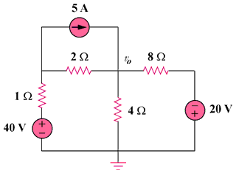

Figure 3.96
For Prob. 3.51.

